Certified Nursing Assistants/Caregivers Flexible Schedules and Monthly Bonus Potential

Sugar Land, TX
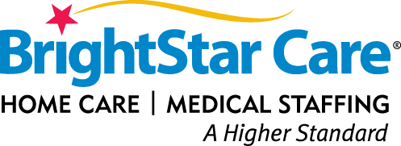

Do you enjoy getting to know people and building relationships that will last?
Do you have a heart for helping those in need?
Our Certified Nursing Assistants, and Caregivers play a major role in our AWARD-WINNING home care team. They work under the supervision of a registered nurse and their client care manager. Our team performs various personal and companionship services to meet our clients’ needs. This allows our clients to maintain their independence for longer periods of time.
We have a commitment to incorporating advanced technology that offers our employees an opportunity to deliver their best performance. Work as many or as few hours as you want, as our team is looking for individuals searching for full and part-time work, nights, days, weekends, and holidays.
We are Joint Commission Accredited and have won the Enterprise Champion for Quality Care Award for 5 years running. We are Home Care Pulse Award Winners of *Employer Choice Award* and *Provider Choice Award* for 2017 & 2018. You may have even seen BrightStar Care on the hit television show Undercover Boss!! We service clients in Sugar Land/ Richmond/West Houston/ Katy areas.
Pay rate $9.50- $13.00 p/hr.
Benefits
- Weekly pay with direct deposit
- Excellent Employee Referral Program
- "Employee of the Month" Elections
- Monthly Bonus Program
- 401K Program
- Holiday & Overtime Pay
- BrightStar Discount Perks ( Theme Parks, Movie Tickets, Rental Cars, Office Supplies and more)
- One to one patient care
- Paid Training for Dementia Certification Program
- Working for a Joint Commission Accredited Agency
- National opportunities with over 300 locations in US
Responsibilities
- Provide client with hygiene care as directed including, but not limited to: bathing, grooming, oral care, dressing, undressing, toileting activities, emptying a catheter bag, linen changes, light housekeeping
- Assist client in active and passive range of motion defined by the plan of care, document observed changes, report any changes to the Director of Nursing
- Develop and promote a safe environment for quality client care through adherence to established policies, procedures, and standards
- Ensure client’s rights and HIPAA to maintain client confidentiality
Requirements
- High school diploma or GED
- Certified CPR (Classes available in office)
- Negative TB skin test or chest x-ray
- Drivers license & Auto Insurance
- Reliable Transportation
- CNA - Minimum of one (1) year of documented experience required.
- Caregiver- Minimum of (2) years of documented experience required.
- Must be available for work one weekend day and every other weekend
- Must be able to work in a household with pets
- Must be available to work days, nights, weekends, short, and long shifts
After submitting your application, please complete survey that will be emailed to you.
We are an Equal Opportunity Employer and do not discriminate against applicants due to race, ethnicity, gender, veteran status, or on the basis of disability or any other federal, state or local protected class.

